# *HAMZA EJAZ*

# *S # B19102041*

# *BSCS-II (Morning)*

# *Section-A*

# *Digital Computers Design Fundamentals*

***Lab File***

**Object:-**

To study operations of Basic Gates; i.e AND, OR, NOT.

**Apparatus:-**

ICs (74LS08, 74LS32, 74LS04), copper wires, breadboard, DC power supply, ground and LED bulb.

**Pin Diagram:-**

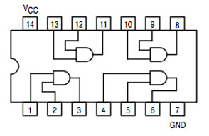

74LS08

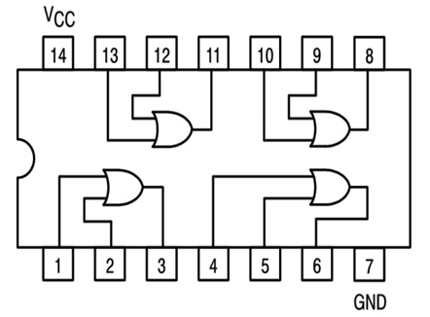

74LS32

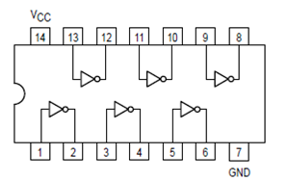

74LS04

**Circuit Diagrams:-**

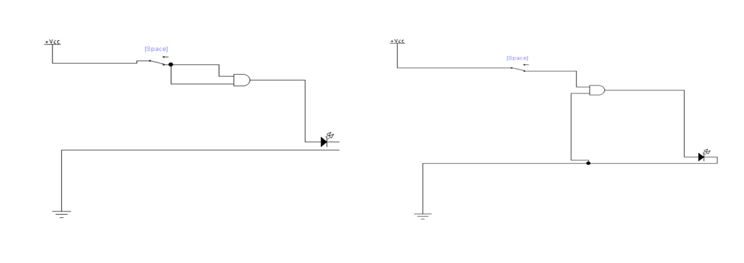

**AND Gate**

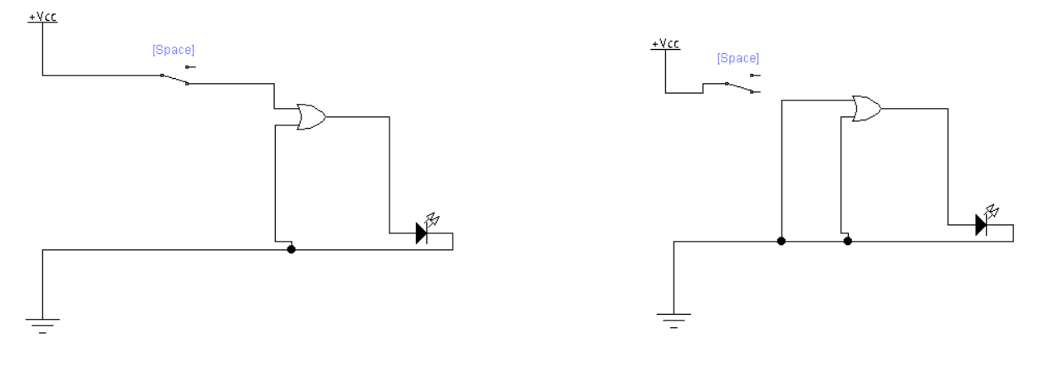

**OR Gate**

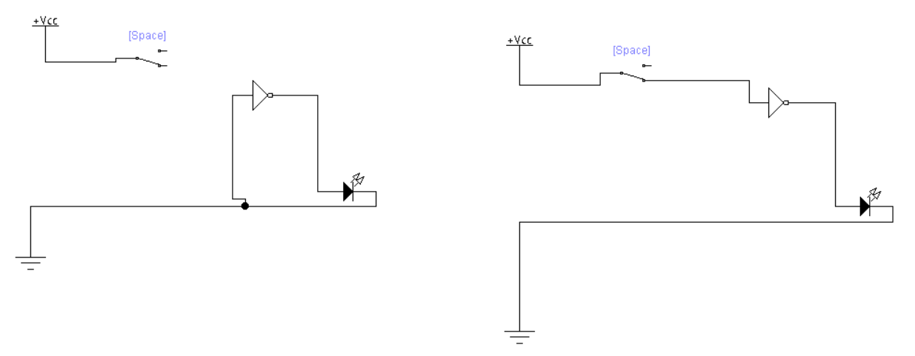

**NOT Gate**

**Truth Table:-**

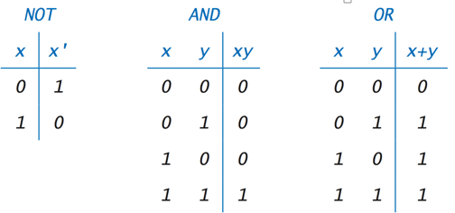

**Conclusion:-**

* When n both inputs are 1/+ Vcc then **AND gate** is producing +ve to the LED bulb and LED is on.
* When at least one input of OR gate is 1/+ Vcc then **OR gate** is producing +ve to the LED bulb and LED is on.
* When the only input of NOT gate is 0/ connected to earth then **NOT gate** is producing +ve to the LED bulb and LED is on.